Project Title: Sales Data Analysis & Profit Prediction App
Instructor: Hagar Hisham
Team Members:
- Ahmed Ali
- Mariem Mohamed Emam
- Youssef Mohamed Elhossien
- Mohamed Khalid Kamal Fahiem (Team Leader)
Course Name: Advanced Data Analytics

Submission Date: September 19, 2026

1. Executive Summary
The Business Question: How can we accurately predict transaction profitability and identify the key drivers of profit and loss across different retail categories and regions?
Key Finding & Recommended Action: The analysis revealed that while Furniture generates high revenue, it yields extremely low profit margins due to high discount rates, whereas Technology (especially Copiers and Phones) drives the majority of net profit. A Random Forest model successfully predicted profit with 92.79% accuracy based on sales and cost data. Action: We recommend revising the discount strategies in underperforming states (like Texas and Ohio) and reallocating marketing efforts toward high-margin Technology products.

2. Problem Statement
Business Question: What factors most significantly impact retail profitability, and can we build a machine learning model to reliably forecast the profit of future transactions?
Why it matters: Retail managers, regional directors, and stakeholders benefit directly from this analysis. By understanding which regions, segments, and categories are operating at a loss, the business can optimize its pricing, inventory, and discount strategies to maximize overall net income.
Scope: The analysis covers historical retail data across the United States from 2014 to 2017, analyzing specific product categories (Furniture, Office Supplies, Technology) and customer segments (Consumer, Corporate, Home Office).

3. Data Sources
- Dataset Name: Retail Sales Dataset (Superstore Sales)
- URL & Access Date: Click Here For More
- (Accessed on: September 19, 2026)
- Size & Granularity: The initial dataset contained 9,993 rows and 47 columns at the transactional level (each row represents a specific item within an order). Time span covers 4 years (2014-2017).

4. Data Architecture / Data Schema
The dataset consists of three primary linked entities:
- Orders: Contains transactional details (Order ID, Product ID, Sales, Profit, Discount, Quantity).
- Returns: Contains binary status for returned orders (Order ID, Returned status).
- People: Maps geographic regions to specific Regional Managers (Region, Person).
- Key Fields (Data Dictionary snippet):
  - Order ID: Unique identifier for the transaction.
  - Sales: Total revenue for the item.
  - Cost Of Items: Calculated cost of goods sold.
  - Profit: Target variable (Net Profit).
- Relationships: The Orders table was joined with Returns on Order ID (Left Join) and with People on Region (Left Join).

5. Data Cleaning & Preparation
Data-quality issues handled:
- Dimensionality Reduction: The raw dataset included massive spreadsheet artifacts (completely empty columns from Column21 to Column32 and Unnamed: 40 to Unnamed: 46). These were dropped.
- Missing Values & Duplicates: Dropped duplicate segments (e.g., Segment2) and removed 15 rows with null values.
- Inconsistent Formats: Standardized strings by stripping whitespaces and capitalizing values. Postal Code was formatted to a 5-character string (zero-padded). Quantity was cast to an integer.
- Impact: The dataset was reduced from a messy 9,993 x 47 matrix to a clean, analysis-ready dataset of 9,979 rows with engineered features.

6. Exploratory & Statistical Analysis
- Descriptive Statistics: The cleaned dataset highlights 5,006 total unique orders, totaling $2.30M in Sales and $287K in Profit, with an average Profit Margin of 12.5% and a 6% Return Rate.
- Visualizations & Patterns:
  - Geographic: Heatmaps showed California, New York, and Washington as the most profitable states, while Texas, Ohio, and Pennsylvania suffered significant losses.
  - Category: Furniture showed high sales volume but marginal/negative profits.
  - Temporal: A steady YoY (Year-over-Year) growth in sales was observed from 2014 to 2017.
- Track Selection Justification: Since the target variable (Profit) is continuous and highly dependent on numerical features (Sales, Cost, Discount), the Predictive/Regression Modeling track was chosen as the most appropriate technique.

7. Technique Application — Modeling
- Chosen Track: Predictive / Regression Track. Fits the problem perfectly as we are forecasting a continuous financial metric (Profit).
- Feature Selection/Engineering:
  - Numerical features: Sales, Discount, Quantity, Cost Of Items.
  - Categorical features: Category, Sub-Category, Segment.
- Model Tried & Final Choice: A Scikit-Learn Pipeline with a ColumnTransformer (OneHotEncoding for categorical variables) was built. Random Forest Regressor was selected for its robust handling of non-linear relationships and resistance to overfitting. Data was split 80/20.
- Evaluation Metrics:
  - MAE: 8.20
  - RMSE: 39.07
  - R² Score: 90.31% (Excellent variance explanation).
  - Feature Importance: Sales (52.0%) and Cost Of Items (30.9%) were identified as the strongest predictors.
- Streamlit App Showcase: A web application was deployed where users can dynamically upload new data (Sales Dataset cleaned.xlsx) and the pre-trained model (profit_model.joblib) to run predictions on the fly and view dynamic EDA. (See Appendix for App Link).

8. Dashboard & Inferred Insights
Dashboard Structure:
- Overview Dashboard: High-level KPIs, YoY Sales trends.
- Sales Dashboard: Metrics by Segment, Category, and Regional Manager.
- Geography Dashboard: State hierarchy and Discount Impact map.
- Products Dashboard: Sub-category deep dives.
Key Insights:
- Discounts are destroying margins in specific regions: Texas and Ohio have aggressive discount strategies that result in negative net profit, despite decent sales volume.
- Category imbalance: Technology is the backbone of profitability (specifically Copiers and Phones), whereas Tables and Bookcases (Furniture) operate at a severe loss.
- Returns Impact: The 6% return rate slightly impacts net sales, but the primary driver of loss remains poor pricing/discount strategies, not returns.
Screenshot of Dashboard: 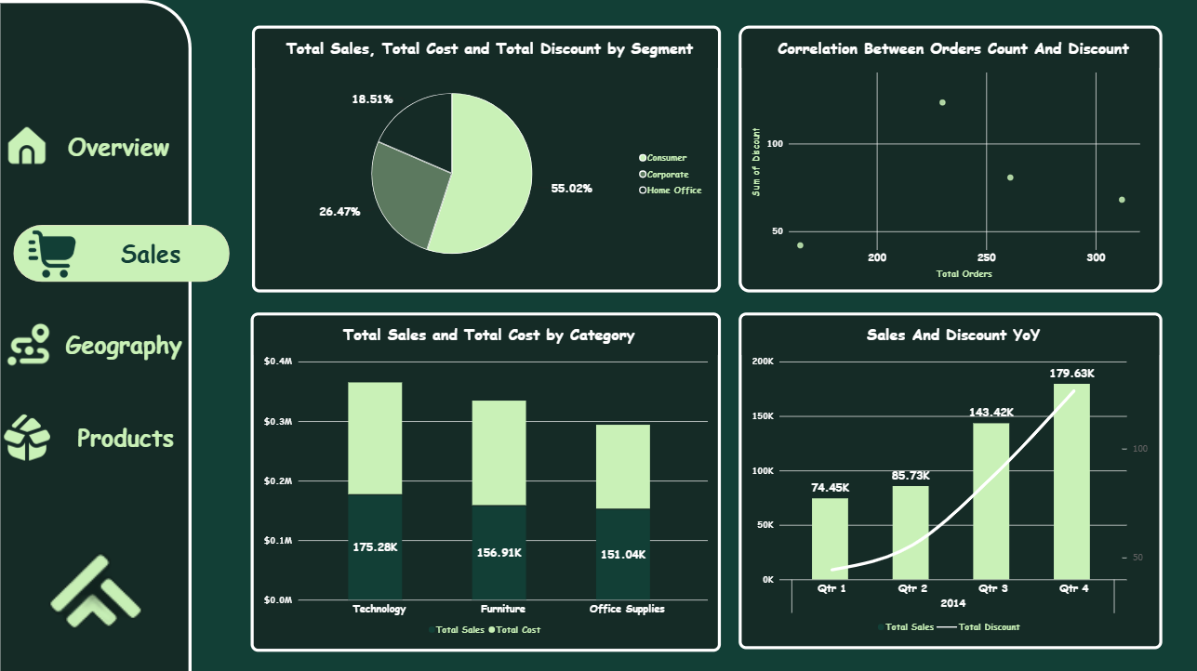

9. Conclusion
- Answer to the original question: Transaction profitability is highly predictable (92.7% accuracy) based on Sales, Cost, and Category. The biggest driver of profit loss is over-discounting in the Furniture category across central/southern states.
- Limitations: The dataset lacks external economic indicators (inflation, competitor pricing, seasonality context) and operational costs (shipping variations, warehouse costs) which might impact real-world net margin.
- Recommendations/Next Steps:
  - Cap maximum discount rates in Texas, Ohio, and Pennsylvania.
  - Reevaluate the viability of selling Tables and Bookcases, or renegotiate supplier costs.
  - Integrate the Random Forest model into the point-of-sale (POS) system to flag potentially unprofitable transactions before they are finalized.

10. Appendices
- GitHub Repo: https://github.com/3arab-star/NTI_Final_Project/tree/main
- Published Dashboard Link: https://app.powerbi.com/groups/me/reports/cd72de56-0e81-43ba-a8bc-c2bb2d7f512c?ctid=37a02594-22f7-411c-9ab1-5bb5e8a6aaed&pbi_source=linkShare
- Full Data Source Citations: Retail Sales Dataset https://github.com/3arab-star/NTI_Final_Project/tree/main

